On image:-> Image\cock-n01514668\n01514668_1208.JPEG

LIME 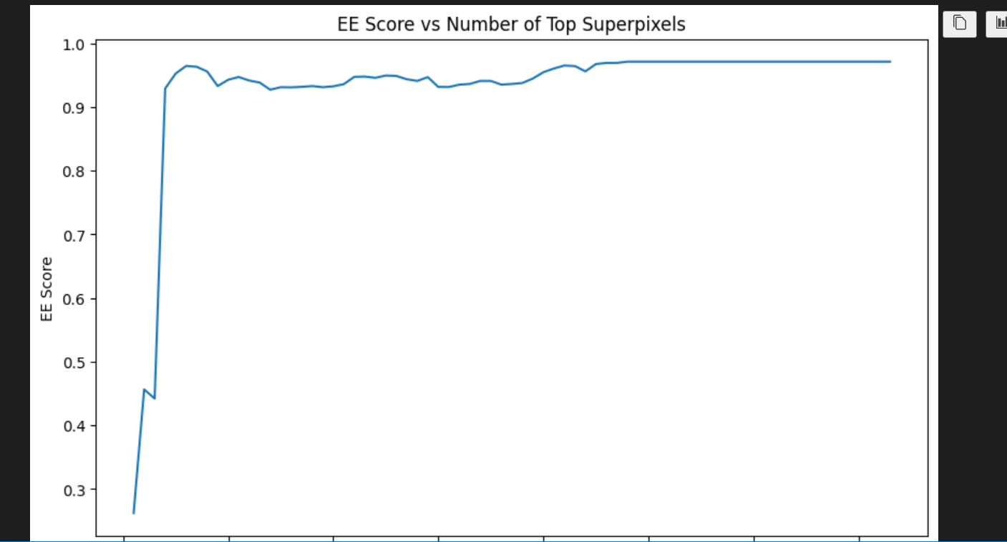

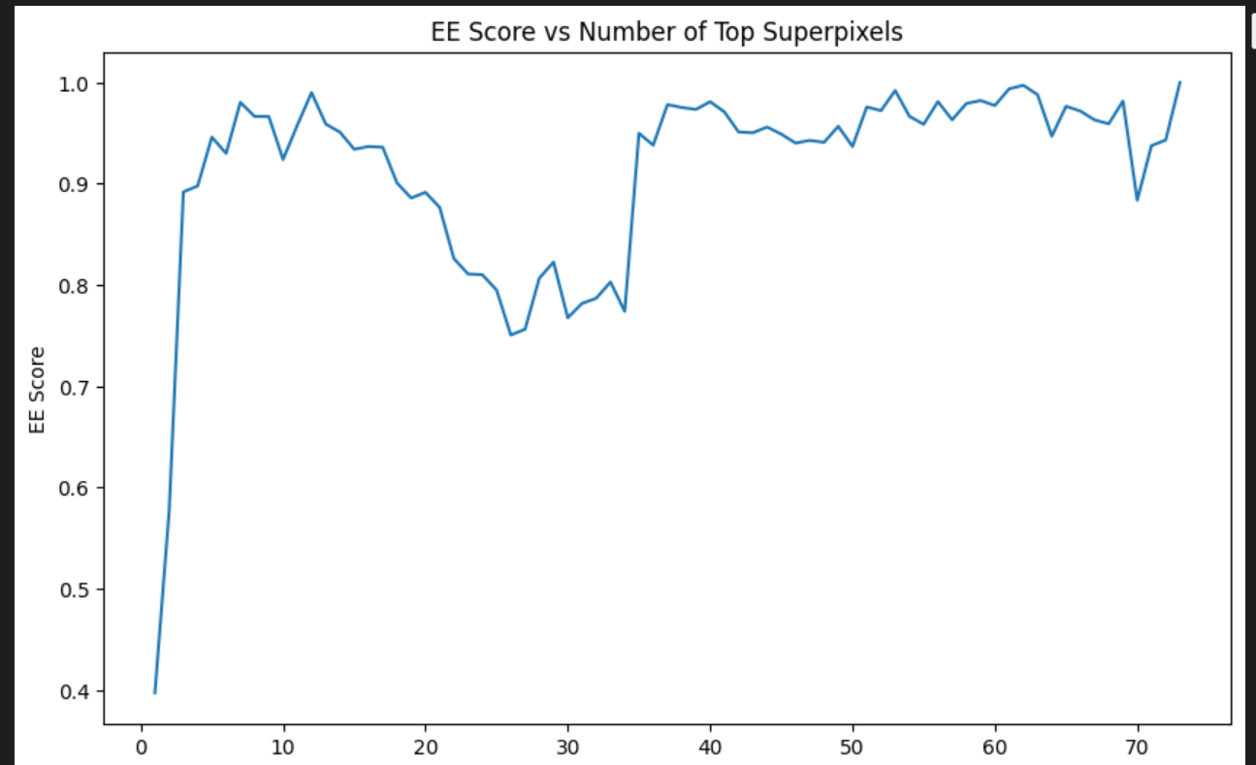

Our code

Image:-> Image\lion - n02129165\n02129165_1065.jpg

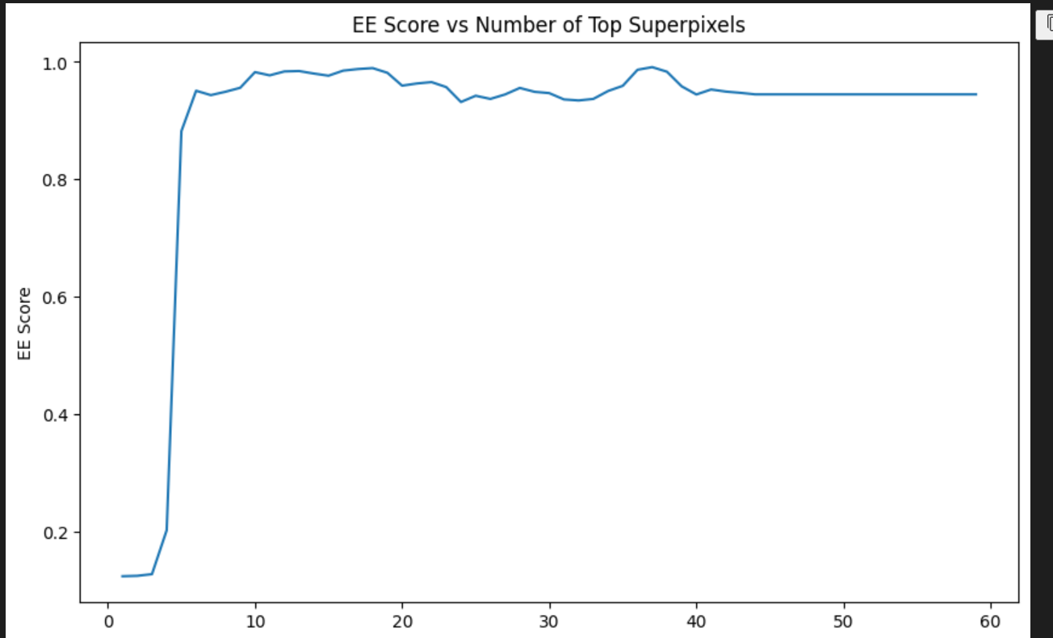Lime

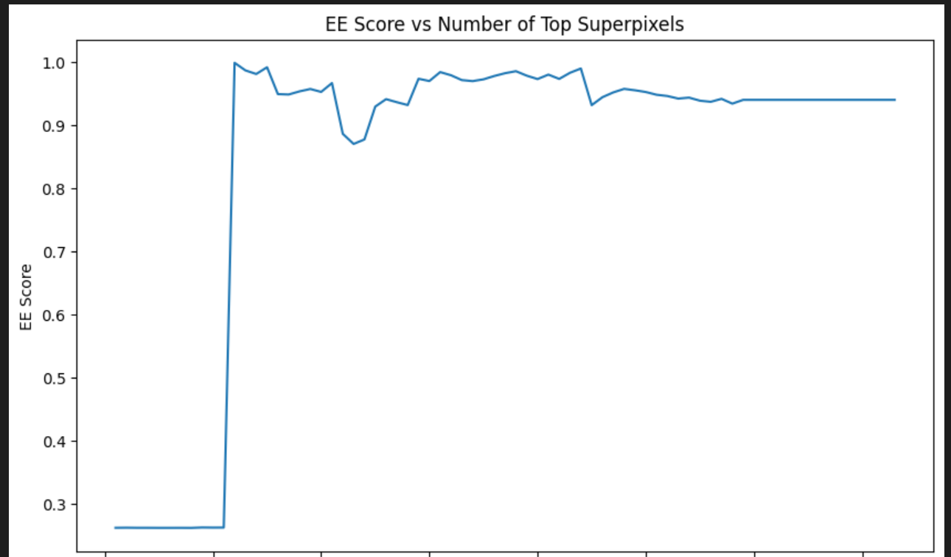Our code